
A 10
SET NO : 1

Sreenidhi Institute of Science & Technology
(An Autonomous Institution)
Code No: 101MA04/111MA04

B. TECH. I – Year II – Semester Examinations, June/July, 2012 (Regular/Suppli.)
MATHEMATICS - II FOR BIO-TECHNOLOGY (BT)

Time: 3 Hours Max. Marks : 70

Note : No additional answer sheets will be provided.

Part-A (Objective Type)
Max.Marks:20

Answer all QUESTIONS.

1. Define exact differential equation.

2. If Laplae transform f(t) is F(s), then find 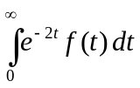.
3. Do the solutions y=e^{x} and y=xe^{x} and linearly independent solutions of the differential equation 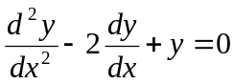.
4. If F(s)=L(F(t)), then what is 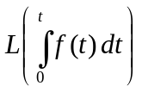.
5. In (-π,π), 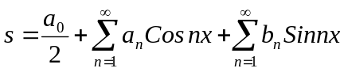, then find a₂.
6. In (-π,π) if f(x)=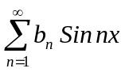then b_{n}=__________.
7. Form the partial differential equation from z=f(x+ct)+g(x- ct).

8. Show that 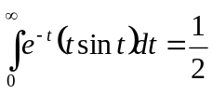.

9. Find orthogonal trajectories of r=a(1-cosθ).

10. Find the particular integral of (D²+3D+7)x=Cos2t.

Part – B
Max. Marks: 50

ANSWER ANY FIVE QUESTIONS. EACH QUESTION CARRIES 10 MARKS.

1. a) Find the differential equation whose general solution is y=ae^{x}+bxe^{x}+ce^{2x}. [ 5 ]

b) The rate of increase of a population at a time s proportional to the size of the population at that instant of time. If the population doubles in 50 years, in how many years will it be trible. [ 5 ]

2. a) Solve y"+4y'+4y=4 cosx+3xinx, y(0)=0; y'(0)=0 ? [ 5 ]

b) If the temp of the air is 20⁰c and the temp. of the body drops from 100⁰c to 80⁰c in 10 min. What will be its temperature after 20 min. [ 5 ]

3. a) Solve (D²+1)y=sec x Tan x by variation of parameters method. [ 5 ]

b) Solve (mz-ny)p+(nx-lz)q=ly-mx. [ 5 ]
4. a) Solve 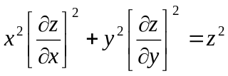. [ 5 ]
b) Solve p-q=x²+y². [ 5 ]

5. a) Find the Fourier series of f(x)=x-x² defined in the interval (-π,π). [ 5 ]

b) Find the half range sine series of f(x)=Cos x in (0,π) [ 5 ]

6. a) Find the Laplace transform t²Cosat. [ 5 ]

b) Find L{f(t)}, where f(t) is a periodic function of period 2Π and it is given by f(t)=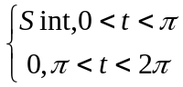. [ 5 ]

7. a) State convolution theorem of Laplace transforms. Using convolution theorem find the inverse Laplace transform of 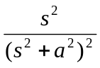. [ 5 ]
b) Solve the differential equation by Laplace transform technique. [ 5 ]
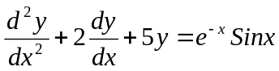; y(0)=0; y'(0)=1

8. a) Find L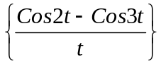 [ 5 ]

b) Find inverse Laplace transformation of 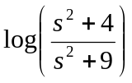 [ 5 ]
-- 00 -- 00 --

